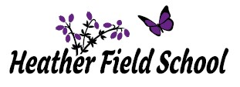

**Newsletter October 2022**

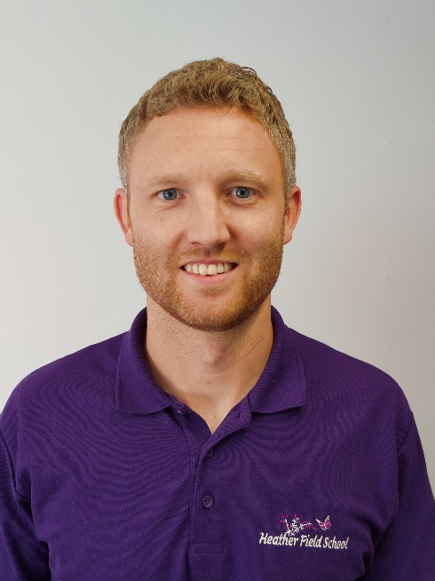

The start of this new academic year has been filled with lots of exciting and fun learning opportunities for our students. These have included celebrating World First Aid Day, National Poetry Day, Age Limitations Day and World Space Week to name a few. For me personally, the start of this academic year has been particularly filled with the hope and anticipation for the fresh challenges that I face as Head of School at Heather Field School.

I have been overwhelmed by the care and commitment that the Heather Field staff team show each and every student in our care and I am incredibly proud to have joined such a dedicated team of professionals. In light of the growing number of pupils that we now have on roll, I am delighted to announce that our Senior Leadership Team has grown too, with the successful appointment of Kelly Butler to Assistant Head Teacher. Kelly is a fantastic addition to the Senior Leadership Team and has already had a huge impact around school with her new role.

As we approach the completion of the first half-term, I would like to thank all parents / carers for your unwavering support. The IEP open day and ‘Meet the new Head’ virtual morning have resulted in me being able to meet so many parents and carers. At Heather Field School we are a family and the triangulation of support between pupils, staff and parents / carers will ensure that all of our pupils flourish.

My door is always open to parents / carers and I welcome an open dialogue so please feel free to contact me on 01785 550940 or [rleech@heatherfieldschool.co.uk](mailto:rleech@heatherfieldschool.co.uk) should you wish to discuss anything.

Upcoming school events to look forward to after half term:

* Remembrance Day
* Anti-Bullying Week
* Road Safety Week
* Children in Need
* Thanksgiving
* St Andrew’s Day
* Pantomime
* Christmas Jumper Day
* Christmas Lunch

**Class Trent**

Class Trent have had great fun in English this half term. Students have studied the topic of ‘My Life, My Choices’ and have explored the importance of young people having a viewpoint. They particularly enjoyed writing emotive letters, expressing how passionate they feel about having the responsibility to make their own decisions regarding their future life choices. Harry was very clear about how much it meant to him to do this activity, stating “I love how I’m getting to say what I want to do. All kids should be able to say what is important to them”. Then, through different fashion trends, Class Trent went on to explore how texts convey viewpoint. They were fascinated to see how trends have changed over the years and found the Macaronis of Georgian England hilarious!

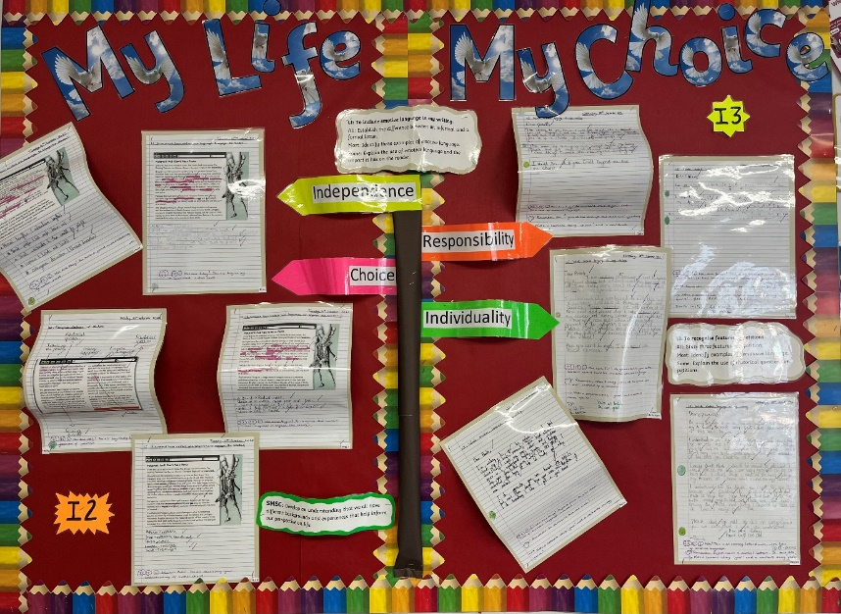

**Class Stour**

Class Stour have really enjoyed their PE lessons this half term. They have been working on basic movements and co-ordination and a highlight was being able to use the parachute. The children’s smiling faces and laughter showed just how much they enjoyed this activity, playing different games around and under the parachute. Stour have also enjoyed their walks to the park and around Cannock Chase and have been practicing sharing their space with other children.

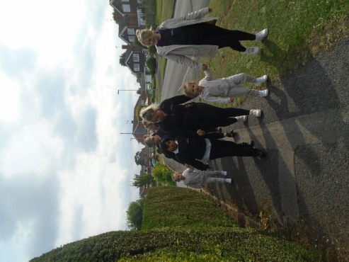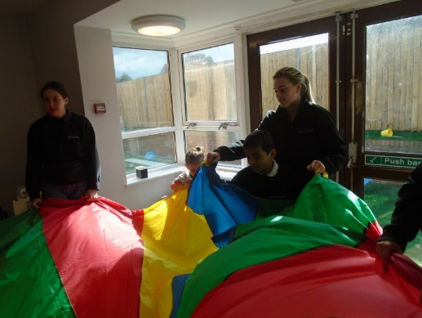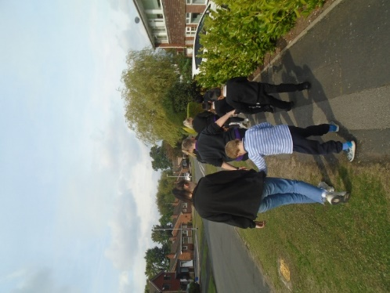

**Class Sow**

Class Sow have enjoyed maths this half term. Key Stage 2 began by working on place value of 3 digit number. They went on to do some brilliant work finding number bonds to 20 and a highlight was Dylan’s use of the part-whole model. Dylan said, “I was very pleased with myself when I figured the question out and won a special sticker”. In Key Stage 3 the pupils worked hard to add 4 digit numbers using the column method. They even managed to do sums which required regrouping. They went on to find multiples of 4 and 6 on a number grid and began to notice common multiples. Vincent said, “I loved it a lot!” when completing the task. Ronnie was Heather Field’s mathematician of the week for his fabulous work on number bonds to 100.

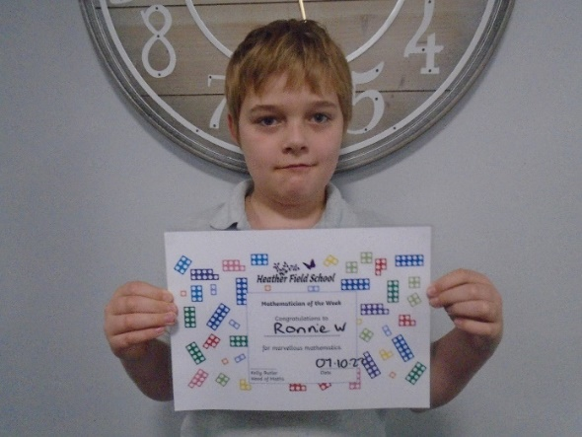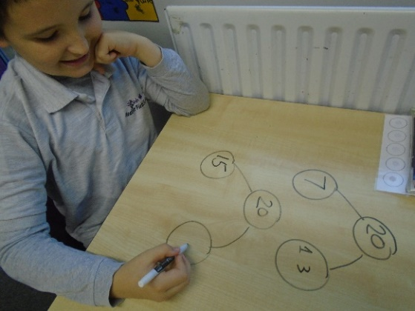

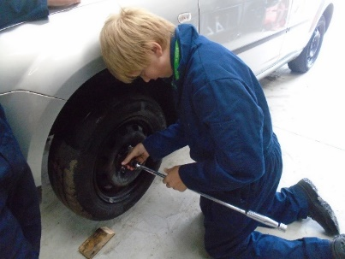  
  
  
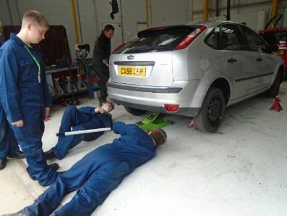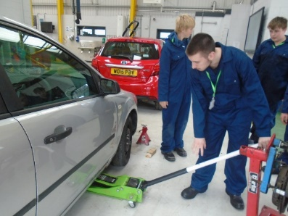**Class Severn**

Class Severn have really enjoyed the start of their motor vehicles this half term. Some of them began with no knowledge of how to change a tyre, and within the first half term of their course, they are now all confidently able to jack up a car, remove a tyre and re-fit a new one! As the weeks have progressed, they are all gaining more and more confidence. Aidan has even said “I think motor vehicles is something I’d like to do at college next year”, whilst Finnley has said “I didn’t know how to change a tire before – but I do now!”. Through doing this new and exciting course at college, they have all worked so hard and demonstrated some fantastic team work skills and social skills.

**Class Penk**

Class Penk have thoroughly enjoyed the topics covered in PSHE this term. We began the term in Key Stage 2 by looking at the importance of healthy eating, the children were able to look at a variety of foods and create a healthy lunch. A highlight of the topic was creating a fruit rainbow, the children used their fine motor skills to safely cut the fruit down before meticulously creating their rainbow on the plates. The rainbows were devoured in class. Maisy said “I love fruit, I do, it’s my favourite” We have the finished off the half term by moving onto road safety and learning how to cross the road safely, this involved looking at different types of pedestrian crossings and a lot of role play.

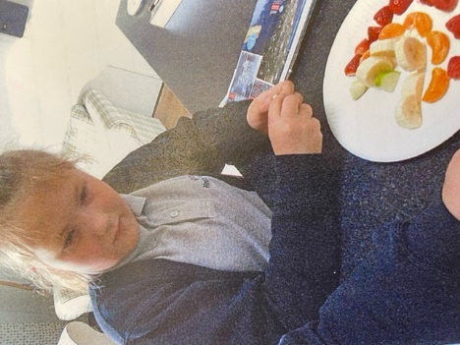

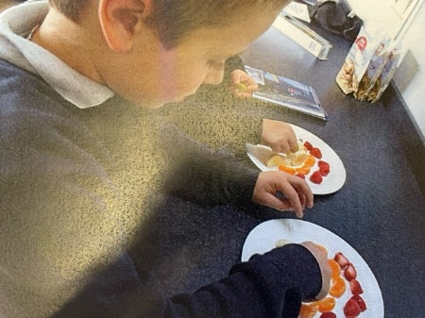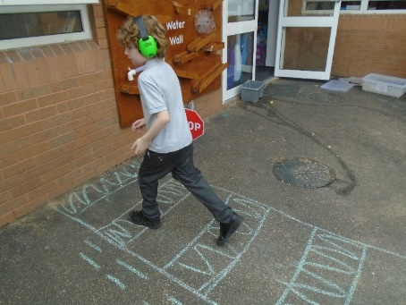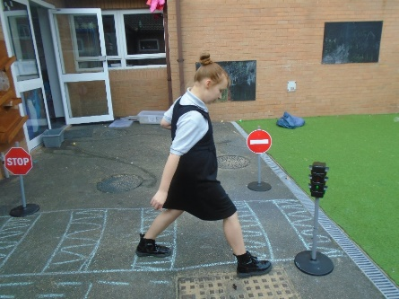

**Class Manifold**

Class Manifold have enjoyed French this half term. They began studying opposites and the use of everyday words. A highlight was showing off their number knowledge by singing the French number 1-20 to different rhymes. Isabella said, “Singing along to the rhymes helps me to remember the numbers”. They then went on to learn about how to assemble basic French greetings and sentences. Anavara used her previous knowledge to ensure that her French pronunciation was correct and she displayed a fluent French accent.

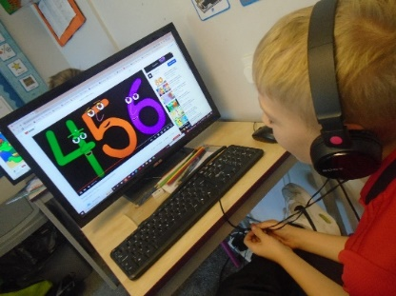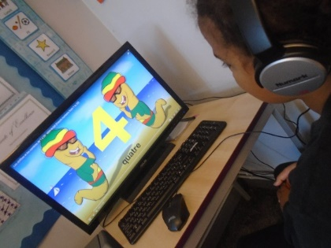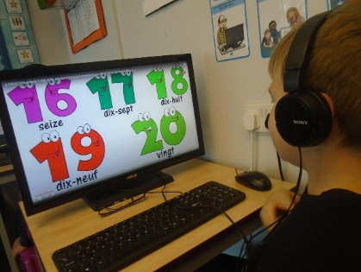

**Class Dove – KS3**

Class Dove KS3 have enjoyed learning about weather and climate during their topic lessons this half term. They began looking at various different weather conditions that occur around the world and then how different aspects of weather is recorded. A particular highlight was the building of a rain gauge that could measure the rain fall. Shayla commented “We cut up a plastic bottle and connected a ruler so we could measure the rain that was collected. It was fun thinking of the best location for it!”

Pupils went on to learn about weather symbols and how and why it rains. Pupils engaged well in a cloud making task with Bailey remarking “It was amazing to see the cloud appear when I changed the pressure in the bottle!” Finally, Kieron particularly enjoyed looking at the different types of clouds that can form.

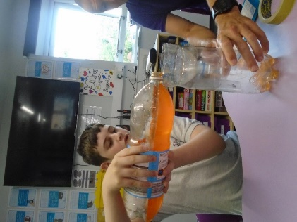

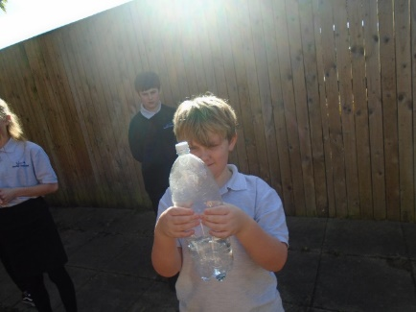

**Class Dove – KS2**

Class Dove KS2 have enjoyed RE this half term. They began studying Buddhism and a highlight was learning about the five promises Buddhist’s keep. Esmai said, “They are very kind people”. They then went on to learn about The Noble Eightfold Path and related this to various scenarios. The children really enjoyed painting pictures of the Bodhi tree, which was used to meditate under. They also loved sharing a session of meditation.

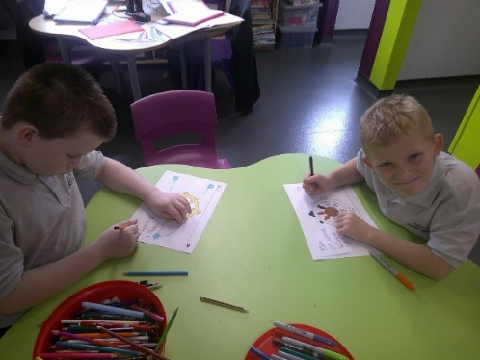

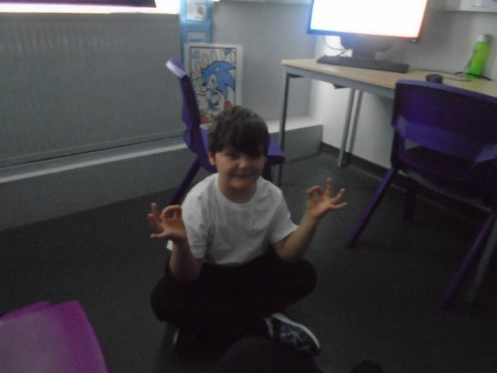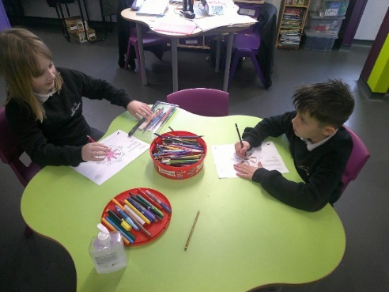

**Class Dane**

Class Dane have enjoyed ICT this half term. They began studying how to stay safe online. The boys all recognised how to keep themselves safe online. They then went on to learn about algorithms, and discussed it is a posh name for a set of instructions. They all created their own algorithm to make a jam sandwich. Their favourite part of the process was following their algorithm to make the jam sandwich, with the most important instruction being to “eat the jam sandwich”.

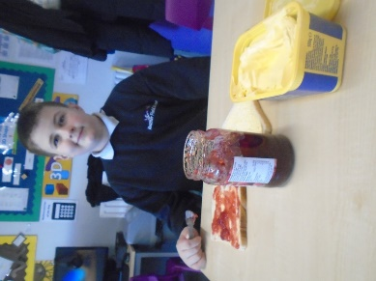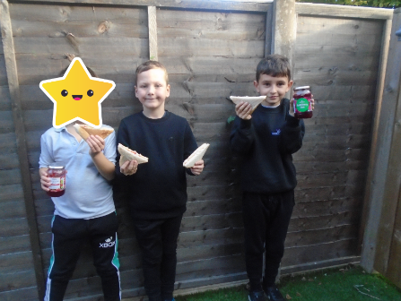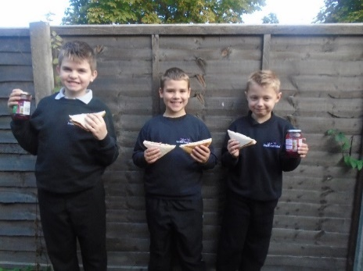

**Class Churnet**

Class Churnet have enjoyed science this half term. They began studying genetics and inheritance and have loved carrying out some practical experiments. They especially enjoyed extracting DNA from strawberries during which Adam said, “So our bodies contain millions of these” whilst pointing at the DNA looking amazed. The class have a keen interest in space and as part of space week enjoyed a trip to Jodrell Bank to look at the lovell telescope.

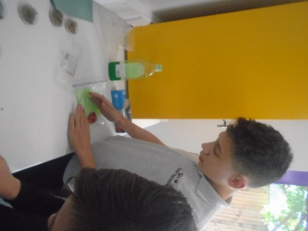

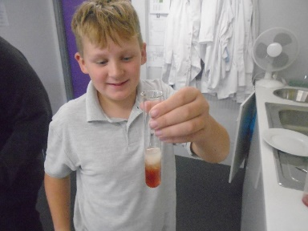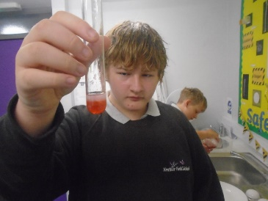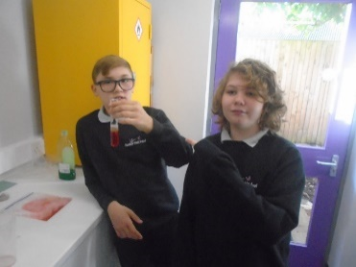

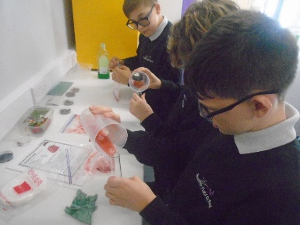

**Class Blithe**

Class Blithe have enjoyed their Social Skills lessons this half term. They began by playing social board games and discussing their experiences of emotions and talked about the way in which they dealt with them effectively. They moved on to working effectively as part of a team, designing and creating a ‘Floor is Lava’ course for the rest of the class to compete on. At the end of the half term; the class turned their hand to cleaning duties, where they did their bit for the school community by keeping gardens and playgrounds clean and tidy.

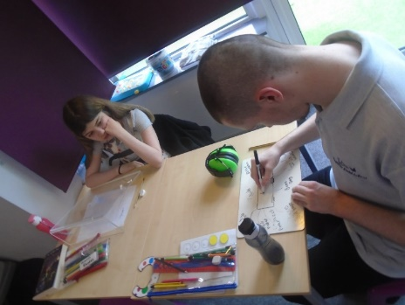

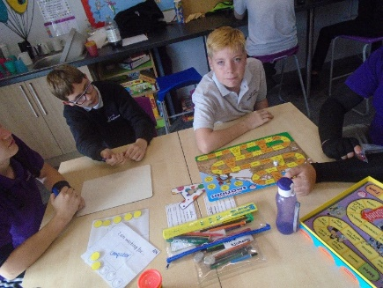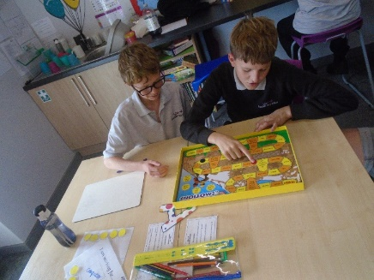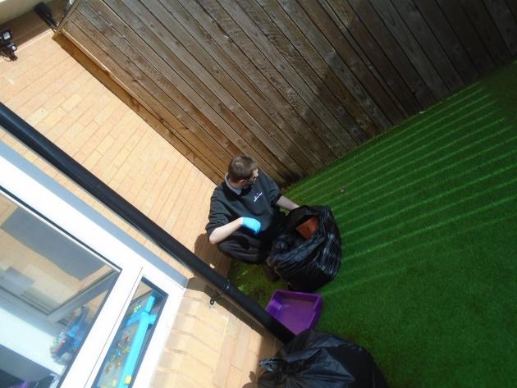

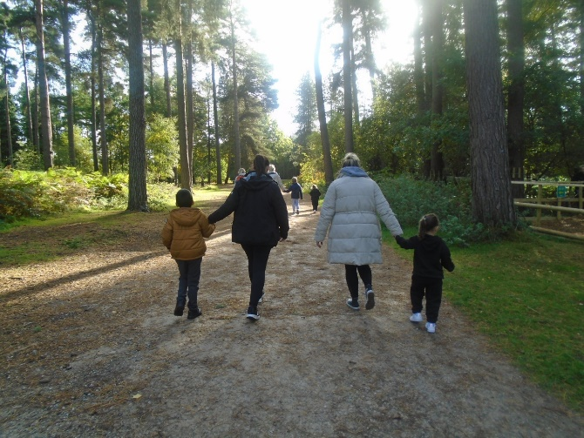

Happy Half Term!

We look forward to seeing you back in school on Monday 31st October 2022.