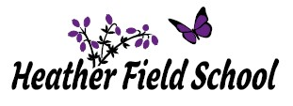
Spring Term 1 2024
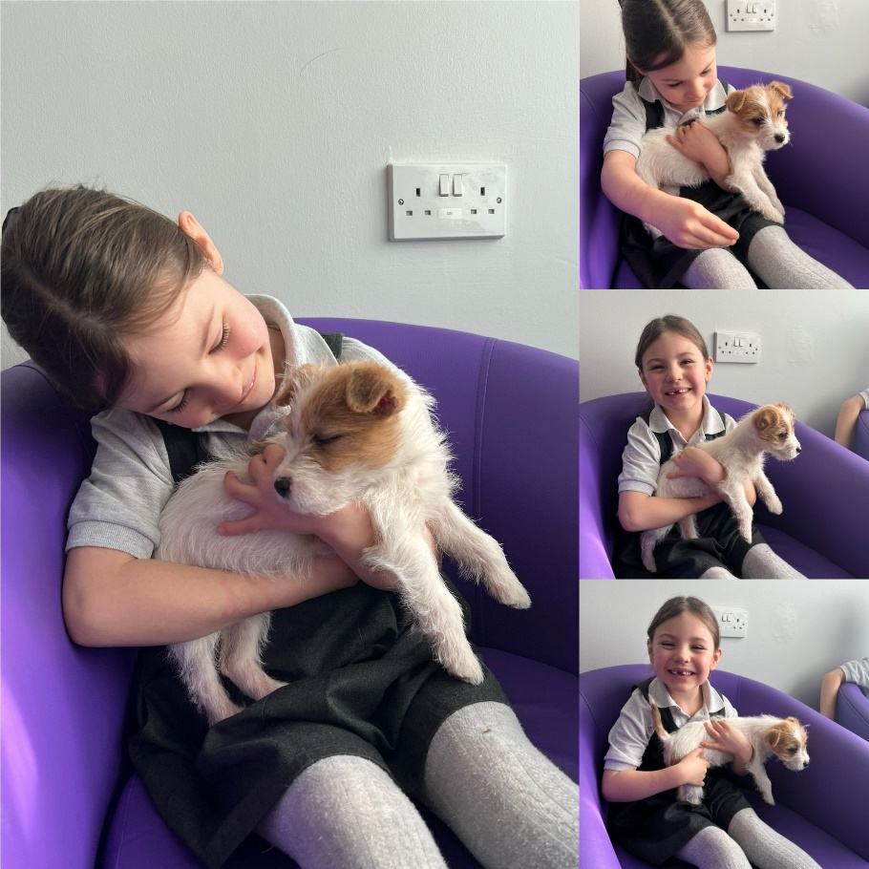
Newsletter

Newsletter February 2024
It’s the end of the first half of the spring term, which has felt very short but sweet! This half term has seen the introduction of our new two-week timetable which I am happy to report has been very well received by both pupils and staff. I think my own personal highlight of this half term has to be the launch of the ‘Heather Field 50’ scheme. We have received some fantastic feedback from parents and carers on this; and it has been lovely to see some parents share their child’s personal achievements of some of the milestones, outside of school. As we embark on a short break from school, I have inserted a copy of the Heather Field 50 below, which might give some families ideas of activities that can be done over the school holiday. If you do complete any of the ‘Heather Field 50’ milestones, we would love for you to share these experiences with us on either the school Facebook group or by sending a picture into the school office: office@heatherfieldschool.co.uk. The exciting new addition of our reading vending machine in the library has also been a highlight of the half term. Pupils who are selected as the ‘reader of the week’, have really enjoyed choosing a book from the machine and it has helped to further promote a love of reading across the school.
I would like to wish all of the school community a happy and healthy half term holiday!
Richard Leech (Head of School)
Upcoming school events to look forward to after half term:
March 2024
01/03/2024 St David’s Day
07/03/2024 World Book Day (get planning your book character outfit everyone!)
4-17/03/2024 Fair Trade Fortnight
12-17/03/2024 British Science Week
14/03/2024 International Day of Mathematics
15/03/2024 St Patrick’s Day
18/03/2024 Radicalisation Diversity Day
21/03/2024 World Poetry Day

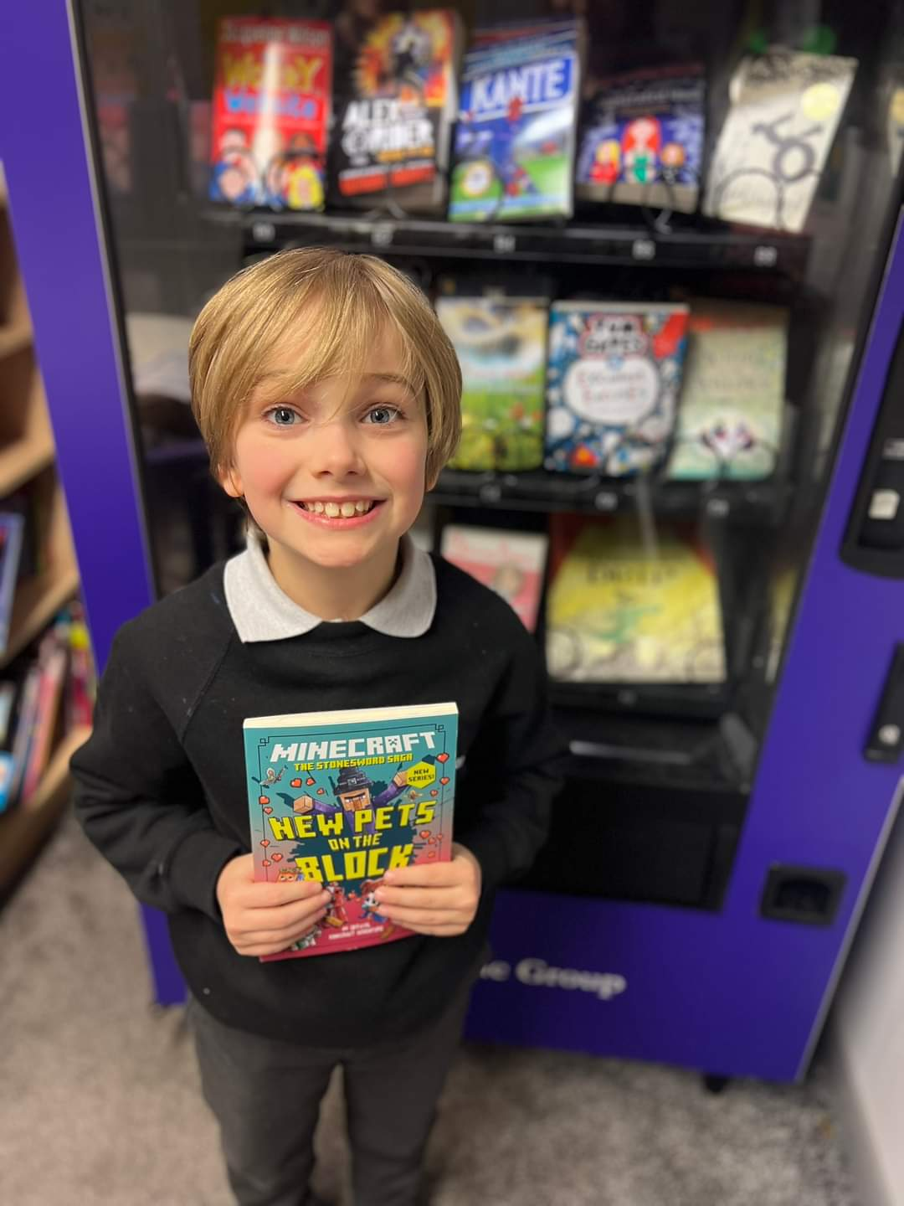

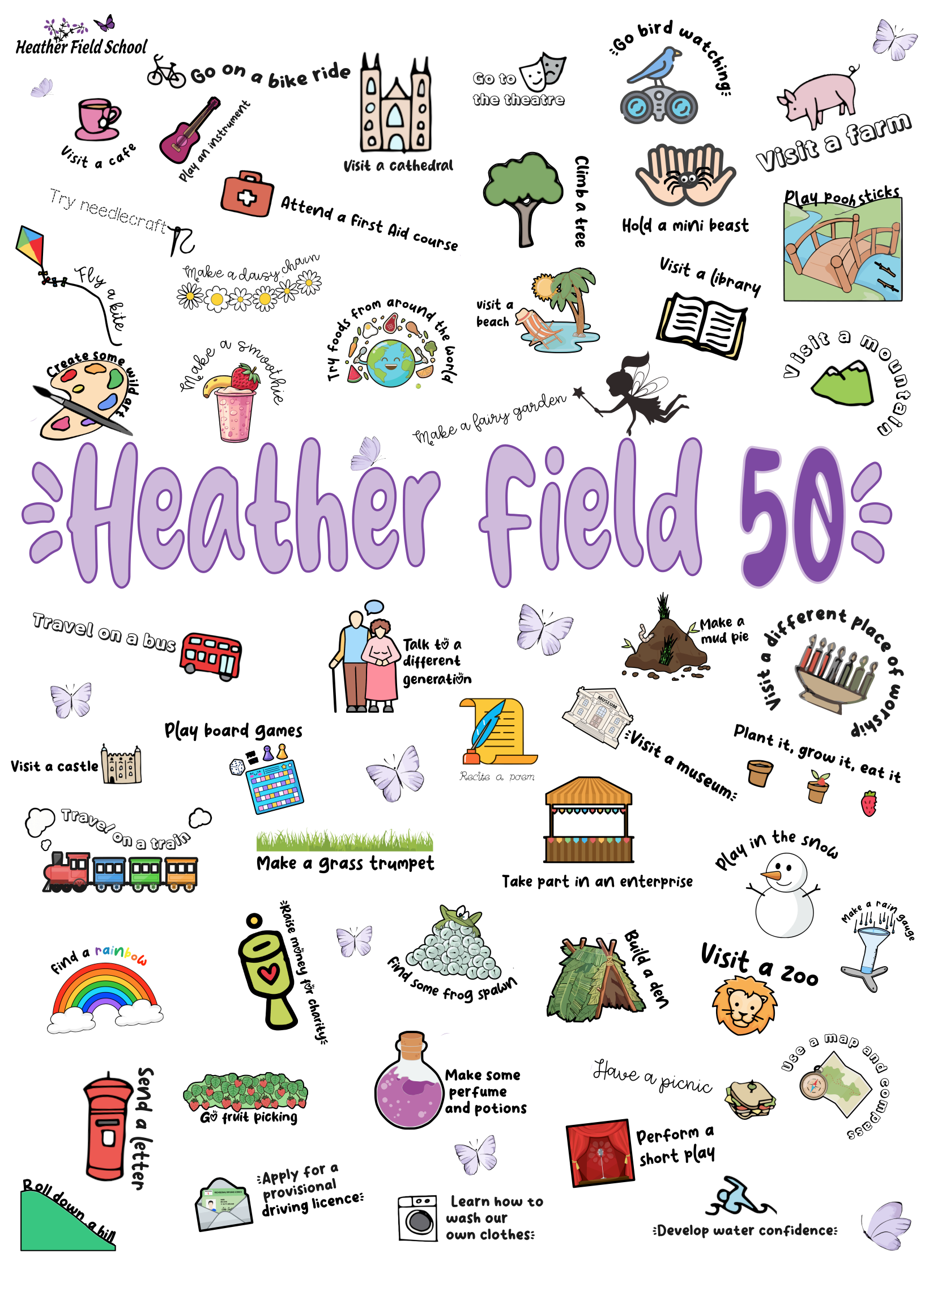

Class Trent
Class Trent have really enjoyed their diversity sessions so far this term. They have covered lots of different topics and have discussed and studied them very positively. They have in particular really enjoyed discussing their personal future aspirations on Aspirational day, where they talked about career options for themselves after school, and set targets for themselves to achieve during this school year!
Class Trent always enjoy any task that involves food! To celebrate Burns Night, they not only learned about the traditions of the celebration, but also tasted lots of different Scottish food and drinks. There are some real Irn Bru lovers in the class!
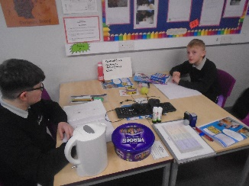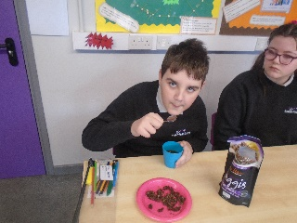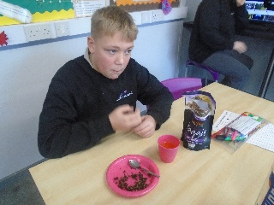

Class Sow
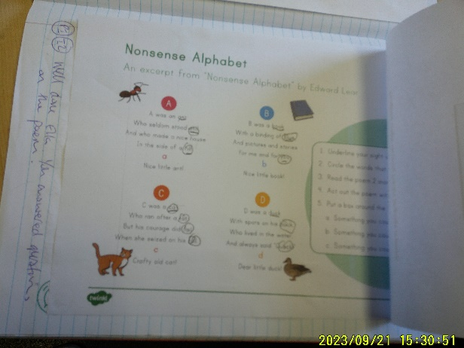
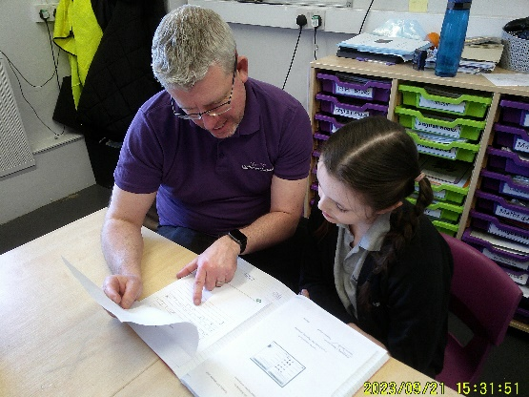
Class Sow have enjoyed English this half term. They began studying the nonsense poems of Edward Lear and a highlight was Ella, who enjoyed thinking of rhyming words. Ella said, “I thought Lear’s poems were pretty good. Rhyming words are nice”. They then went on to write their own nonsense poems. KS3 students have been reading non-fiction texts, finding examples of fact and opinion. They enjoyed reading an extract of American notes by Charles Dickens.

Class Severn
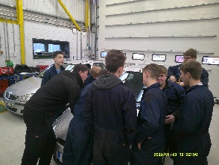
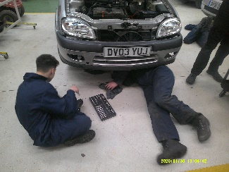
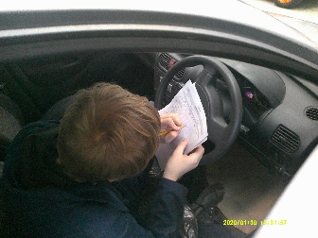
Class Severn have worked really hard this half term whilst at Rodbaston on their mechanics course. So far they have changed breaks, break pads, calipers and tyres. All of the class are able to change the oil in a car and also take off and put back on a tyre. They continue to show a high level of maturity during their course and always work hard throughout the morning. They are working more independently whilst maintaining a high level of health and safety standards. We are proud of the life skills they are learning and we understand that some of the class already use these skills in the the outside world to help out with their families.

Class Penk
In Art this term Class Penk began by developing their artistry skills using a variety of different methods. In line with our topic on Rivers and Mountains the children were able to look at how we can create tone and texture using just a pencil, the children did a great job developing their own skills whilst sketching a picture of a riverbank scene. In contrast, the children were then able to create a similar scene but this time as a collage using different shades of blues and greens to form their pictures. In our final week the children began to explore Monet’s garden and looked at the techniques he used to create his world famous art work.
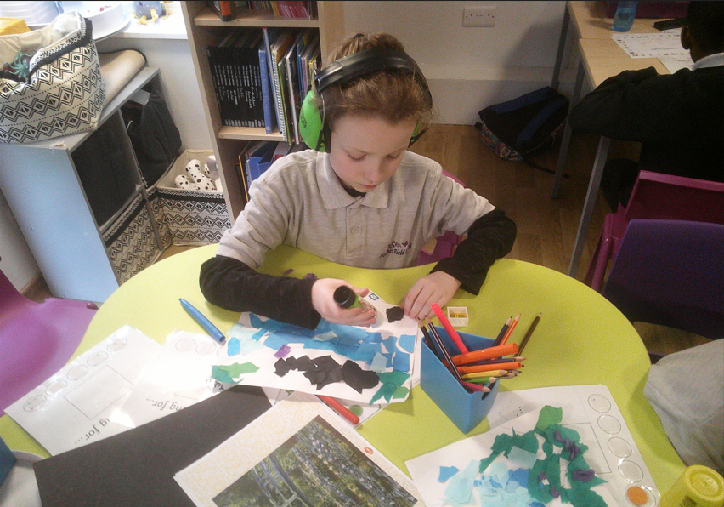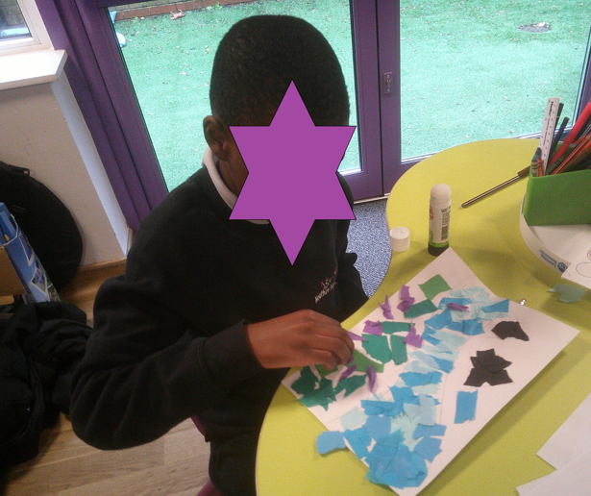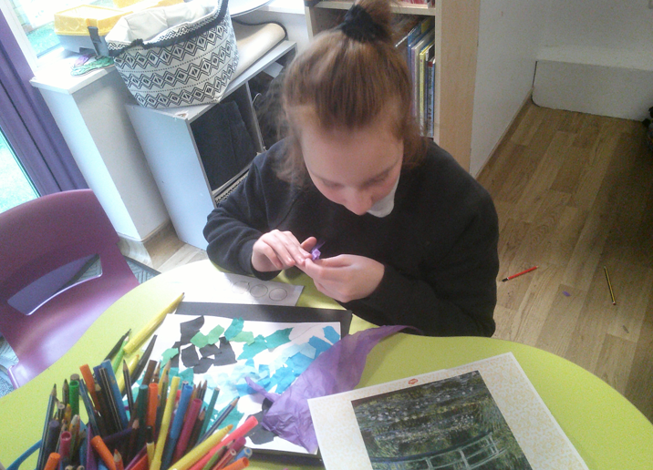

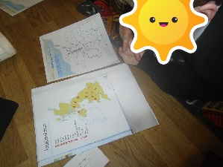
Class Waldron
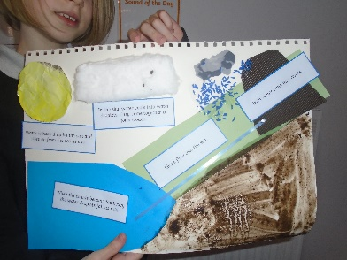
KS1 pupils have been exploring oceans in their geography lessons this term. They have developed their map skills, locating the world’s five oceans on a globe and atlas. The pupils were introduced to north, east, south and west, and used this to locate seas surrounding the United Kingdom on a map. Jayson was really excited to use a compass for the first time, exclaiming “I feel like an explorer!”.
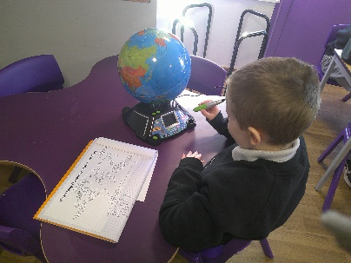
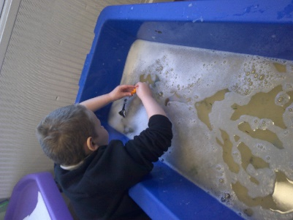
KS2 pupils have been focusing on rivers in geography. They were able to locate some rivers on a map of the United Kingdom. The pupils also learnt all about the water cycle, creating some fantastic posters. Bodhi remembered the term ‘evaporation’ from previous science lessons, and showed great understanding of the water cycle when he said “The sun evaporates water from the sea, and then it turns into clouds!”.

Class Manifold
As part of their PSHE this term, Class Manifold have been exploring the topic of health. They began by exploring the nature of stress and identifying strategies they can implement to help them manage stressful situations. They wrote their own recipe for happiness, identifying what they need in order to feel contentment. Students discussed worries they may have and explored ways of exploring and managing these worries. They created their own water lily of worries which they placed on water and as the flower’s petals opened, the centre revealed how students feel when they have addressed and dealt with their worries. Malaki was amazed by what he called ‘the magic’ and commented ‘That’s so cool!’.
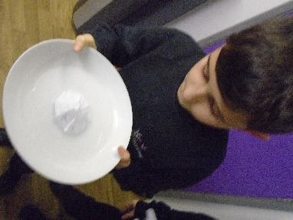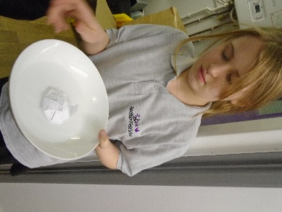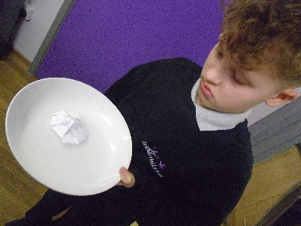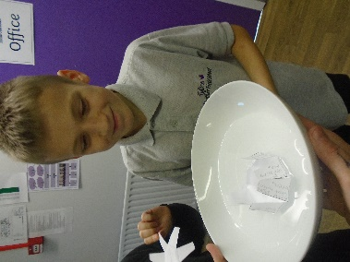

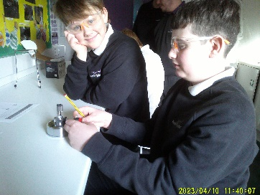
Class Dove – KS3
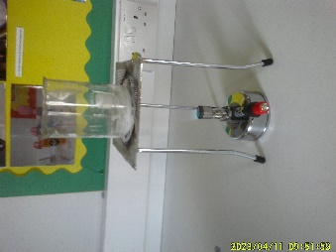
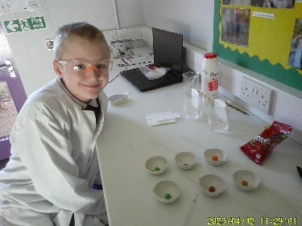
KS3 Class Dove have enjoyed their science lessons this half term where they have focused on mixtures and separation. Students have had lots of practical activities ranging from learning how to use a Bunsen burner safely to measuring the solubility of salt in water, and then how to separate solids from water. Class Dove have also used chromatography to separate solutes, which Patrick really enjoyed and said was “such a cool experiment!”. McKenzie was excited to set up a Bunsen burner and apply his safety equipment, and said “this is the most fun science lesson I’ve had!”. Great work everyone!
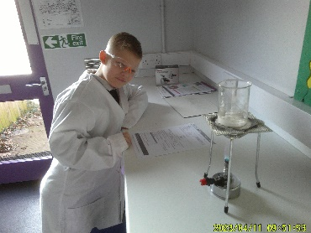

Class Dove – KS2
As part of their maths this term, Class Dove KS2 have been using Numicon to solve problems, find place value and add decimal numbers. They also used cubes for adding and subtracting numbers. Pupils did an amazing job using different measuring tools to find the length and height of different objects and then compare them. Esmai said “Everyone should know how to measure objects.” and commented ‘This is so easy to use!’ referring to the measuring tape.
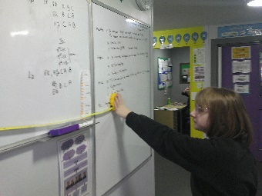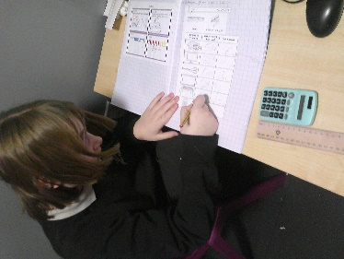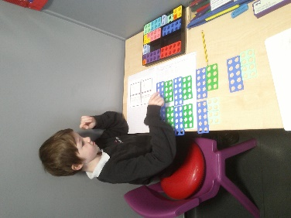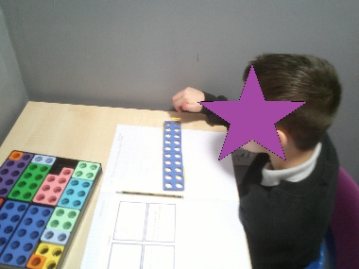

Class Dane
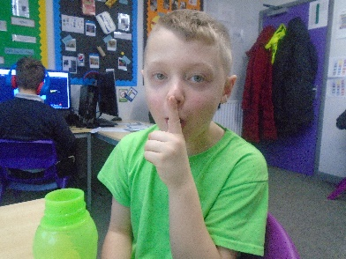
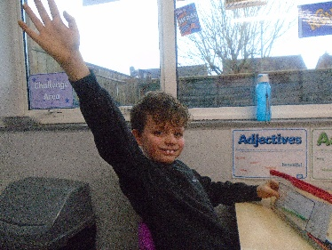
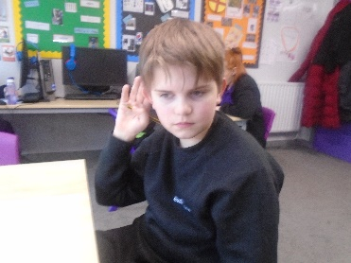
Class Dane have enjoyed French this half term. They began studying classroom instructions and a highlight was when they played ‘Simon Says’. Joshua said, “I think I’m really good at this, I can remember lots of French”. They then went on to learn about numbers up to 100. Harley was able to use his maths knowledge and combine it with his French knowledge.

Class Blithe

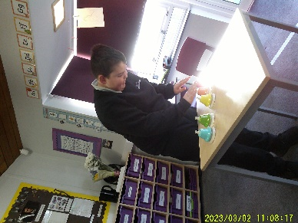
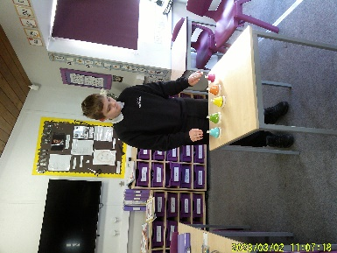
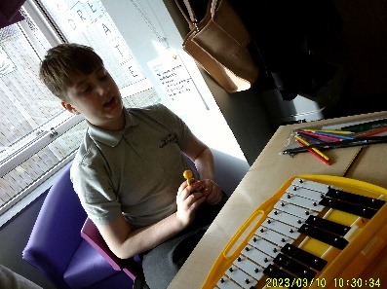
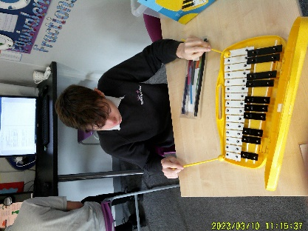
What a wonderful start to the year class Blithe have had in their music lessons. Pupils have been focusing on building their confidence in solo performances. Pupils have stood up
at the front of class and performed using a variety of instruments. Ronnie said that creating his own tune in music has been his favourite lesson so far.

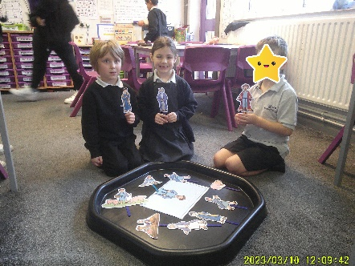
Class Meese
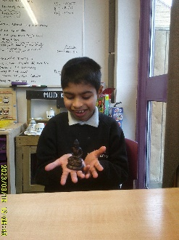
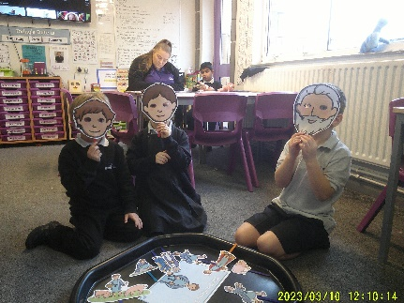
Class Meese have enjoyed RE this half term. KS1 Pupils began by identifying their important possessions and discussed why they are special to them. They have listened carefully to a range of parables from the Bible and discussed the moral of each story. When discussing the morals, Noah said that “it is important to share and be kind to others.” The children have thoroughly enjoyed taking part in role play activities including stick puppets to re-tell each parable in detail. KS2 pupils have been learning about the importance of The Buddha and his teachings. They have enjoyed listening to various Buddhist stories. Whilst listening to the stories and teachings, Rishi described the Buddha as “kind, helpful and wise.”

Class Churnet
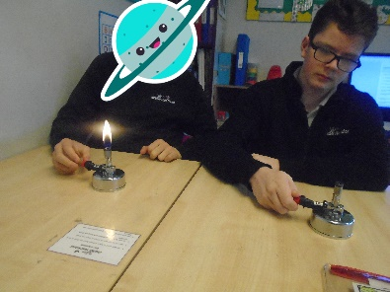
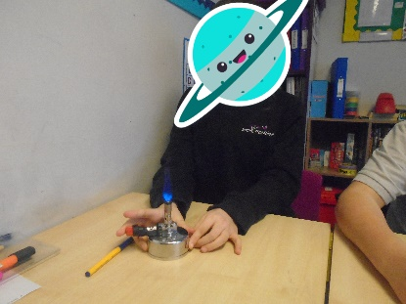
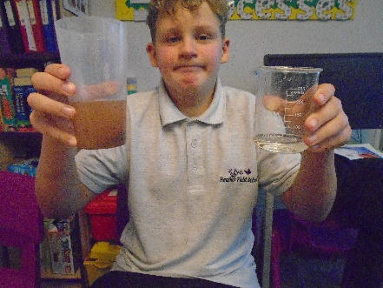
Class Churnet have thoroughly enjoyed Science this half term. They have been studying ‘mixtures and separation’ and have carried out a variety of methods on how to separate different solutions and mixtures. A highlight was when they used filtration to separate sand from water and were amazed that even the colour of the water turned back to clear. They went on to explore chromatography and evaporation.

Class Stour
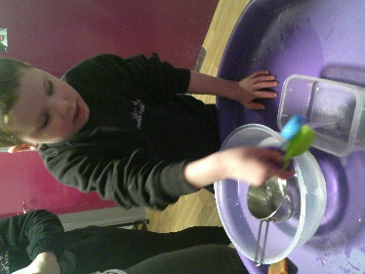
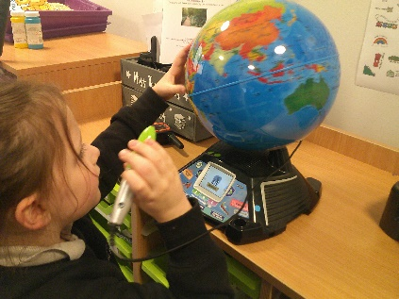
Class Stour have enjoyed Geography this half term. KS1 began exploring the seas surrounding the UK alongside beginning to identify the different continents in the world. Amelie and Florence enjoyed decorating the seas which surround the UK with a variety of animals. Reef and Adar used the interactive globe to learn the names of the different continents and began to find specific places they have visited or would like to visit.
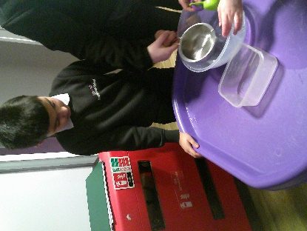
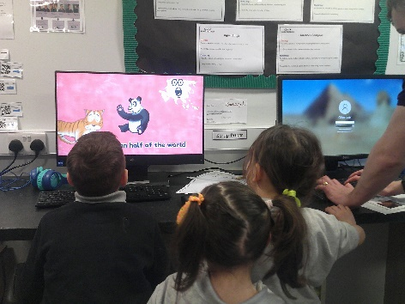
KS2 have focused on finding water sources around our school, thinking about the different daily functions we have for water. Aarav and Agam were able to identify lots of sources outside including outside taps and pipes. Nathania identified ‘swimming’ as a function that we have for water’ and George modeled taking a shower as something he uses water for. They then began to investigate if water holds a specific shape. The children enjoyed water play, transferring water between containers to answer the question.

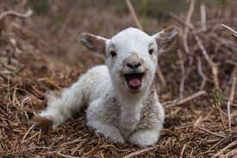

Have a Great Half Term
We will see you all on Monday 19th February 2024

