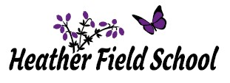
Autumn Term 1 2023
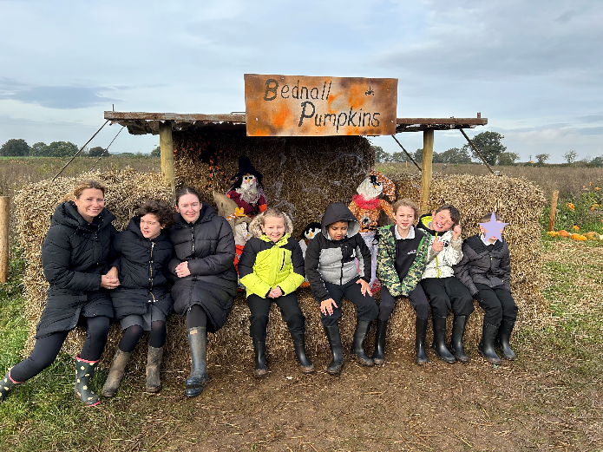
Newsletter
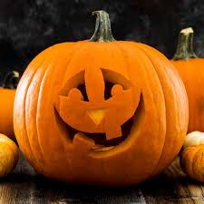

Newsletter October 2023

The start of this new academic year has been filled with lots of exciting and fun learning opportunities for our students. These have included celebrating Recycling Day, National Fitness Day, Wear it Wild Day, Mental Health Awareness Day, World Food Day and E-Safety Day to name a few!
I would like to take this opportunity to inform you of some changes to the Senior Leadership Team. The opening of our sister school ‘Cherry Tree’, in September, meant the departure of Kelly Butler. Kelly was successfully appointed as the new Head of School for Cherry Tree in Walsall. I would like to officially congratulate Kelly on her new role and to thank her for all of her hard work and dedication that she gave during her time at Heather Field. As a result of Kelly’s departure and the continued growth of the school, it gives me great pleasure to welcome Tarnya Tokeley and Gary Cornwell to the Senior Leadership Team, who have both been appointed as Assistant Head Teachers. Tarnya and Gary have been with the school for a number of years and will both add a lot of valuable experience to the Senior Leadership Team. Jennifer Newton (Deputy Head Teacher) and Karl High (Assistant Head Teacher) also remain ever present and essential members of the Senior Leadership Team for the 2023-24 Academic Year.
Upcoming school events to look forward to after half term:
- Remembrance Day
- Anti-Bullying Week
- Road Safety Week
- Children in Need
- Healthy Mind Day
- St Andrew’s Day
- Pantomime
- Christmas Jumper Day
- Christmas Lunch
As we approach the completion of the first half-term, I would like to thank all parents / carers for your continuous unwavering support. The IEP open day and the first coffee morning have resulted in us being able to meet with so parents and carers. At Heather Field School we are a family and the triangulation of support between pupils, staff and parents / carers will ensure that all of our pupils flourish.
As you all know, my door is always open to parents / carers and I welcome an open dialogue so please feel free to contact me on 01785 550940 or rleech@heatherfieldschool.co.uk should you wish to discuss anything.

Class Trent
In French this half-term, Class Trent have been learning about different foods and how to develop their understanding of reading, writing and speaking conversationally in French. During lessons, they have discussed the things that they like to eat and don’t like to eat, and have worked independently to translate and learn how to say their sentences in another language. Class Trent have worked very hard at this, and as a result have shown great progress in French!
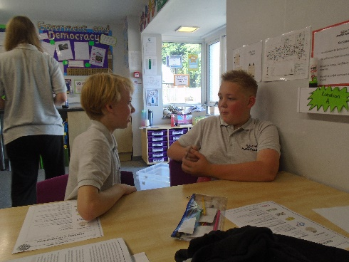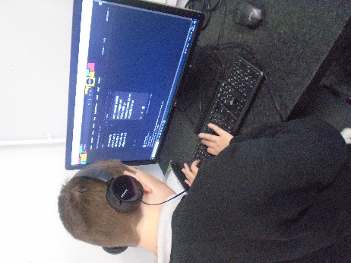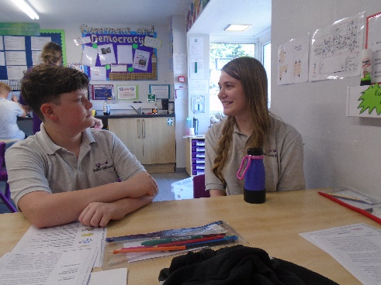

Class Sow
Class Sow have enjoyed RE this half term. KS3 began studying peace and conflict and a highlight was learning about the Baha’i faith and significant buildings that support their Religion. Dylan said, “I liked learning about the war and I find it really interesting”. They then went on to learn about peaceful co-existing communities such as Corrymeela and Neve Shalom. Dylan’s war and peace collage stood out for expressing his feelings on war and peace well. KS2 learnt about community and belonging which explored what community is and which communities they belong to. Ella did particularly well learning about organisations in the local community that help people such as house of bread.

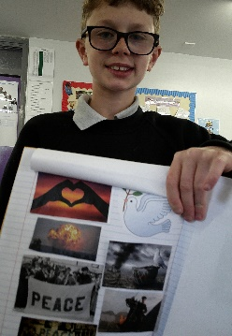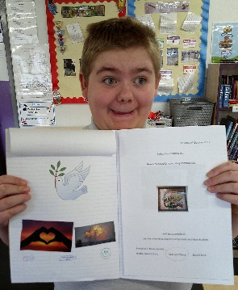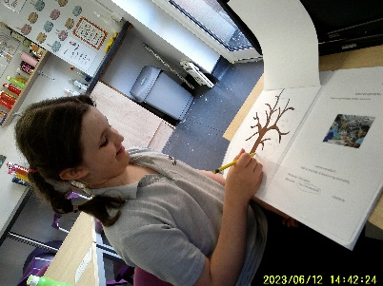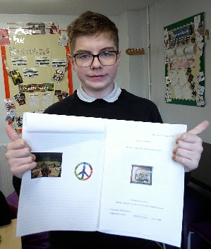

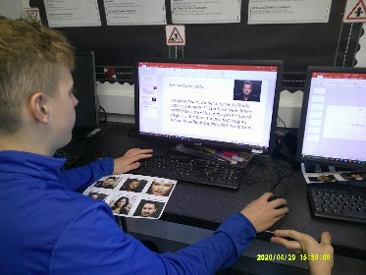
Class Severn
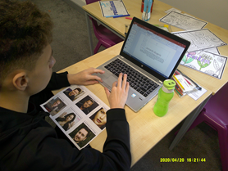
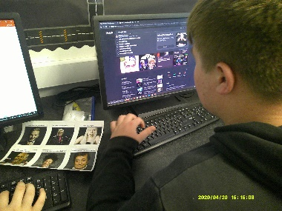
Class Severn have enjoyed using computers as part of their lessons this half term. They particularly enjoyed it on mental health awareness day where they used the computers to research celebrities who have suffered with their mental health and find out about their experiences and what support they used to help them through it. This then led us to a discussion about some of the reasons why celebrities might suffer with their mental health. Class Severn have also been using the computers for part of their Work Skills BTEC lessons, where they have completed skills assessments, which provide career suggestions to suit their skills and qualities. Shane somehow managed to beat the system and said “My assessment hasn’t matched me with any career suggestions”, but after a discussion with the teacher, Shane realized it may have been because a lot of the answers he gave were ‘it depends’. Shane and his teacher then discussed what he wanted to do in the future and he explained how he wanted to be a physicist.

Class Penk
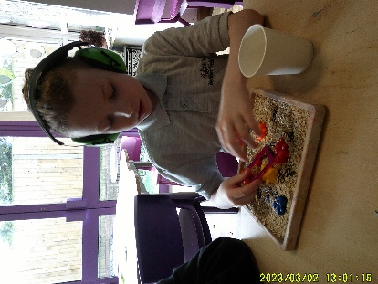
Class Penk have had a fantastic half term in science. Our topic for this term is materials and the children have loved becoming little scientists to discover, observe, analyse and explore the different materials. The children started off the term by looking at different materials and what they were used for, Harry was very proud when he was able to tell us “The climbing frame is made of metal, wood and plastic” The children were then able to explore further by looking into how we can use sieving, magnets, filtering and evaporation to separate the different materials. The children were truly put to the test one morning when our alien Zog sent us a recipe for soup, however soon into our cooking session we discovered he had sent us the wrong one, there was only one thing for it, we now needed to separate the materials and start again. James enjoyed telling Rich all about his adventure using some fantastic scientific vocabulary “First we had to sieve the marbles out, then we filtered the sand and then we had to evaporate the water so we had the salt”. Well done Class Penk you have been fantastic little scientists.
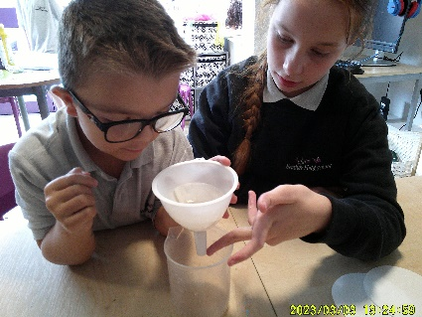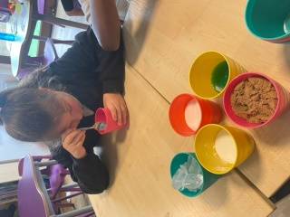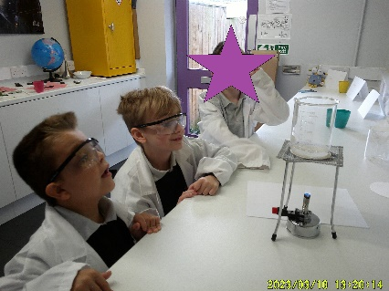

Class Waldron
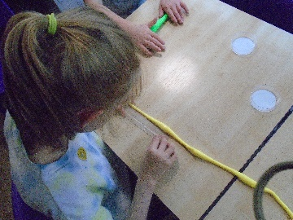
Class Waldron have enjoyed Maths this half term. They began studying place value and a highlight was creating their very own place value kites! B especially enjoyed using a dice to create a number before partitioning it into 10’s and 1’s. They then went on to learn about how to measure lengths and heights and enjoyed using a ruler to measure a range of objects in cm and recording their data using a graph. Lastly, we explore volume and mass! Children especially loves using a scale and measure cups when solving problems!
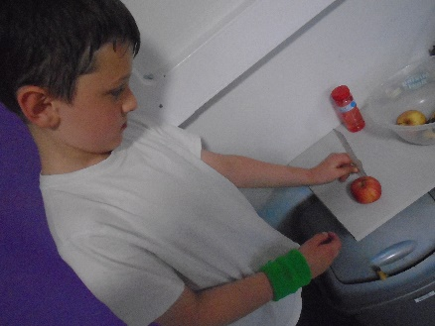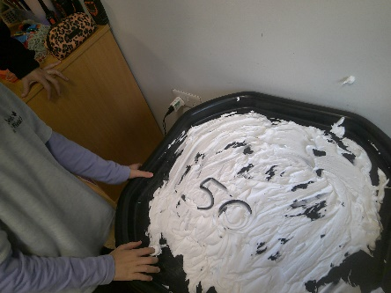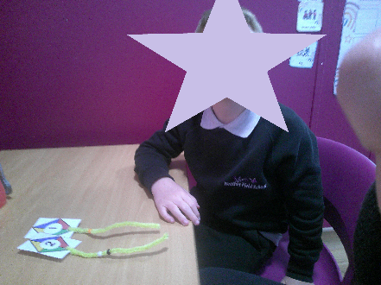

Class Manifold
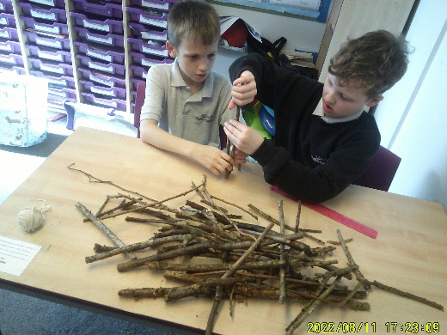
Class Manifold have had great fun in Design and Technology this half term. Students have studied the topic of ‘Invaders and Settlers’ and have explored what life was like living in Anglo-Saxon times. They particularly enjoyed designing and making their own model size Anglo-Saxon house, remaining true to the period, using only natural materials from the local area. They were shocked at how difficult it was and were able to sympathise with the Anglo-Saxons. Lewis remarked “If this is so difficult for us, just imagine how tricky it was to build a whole village! It must have taken days or even months!’ Through studying the Bayeux Tapestry, Class Manifold discovered how much of what we know about the Anglo-Saxon period comes from stories embroidered onto fabrics. Students loved attempting to tell stories of their own through their own embroidery creations.
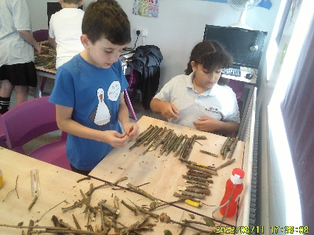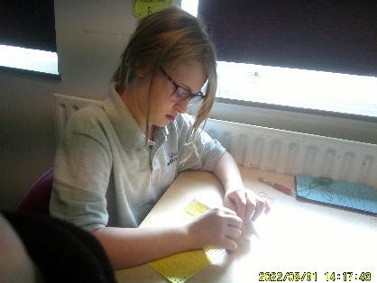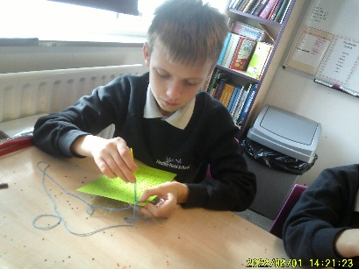

Class Dove – KS3
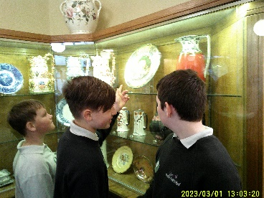
Class Dove have enjoyed history this half term. They began studying the Industrial Revolution, where they identified the changes that occurred in industry. Through this they enjoyed seeing how the country developed into towns that we know today. During the half term the highlight was a visit to Middleport Pottery the home of Burleigh, where they saw first-hand some of the changes that occurred during the Industrial Revolution.
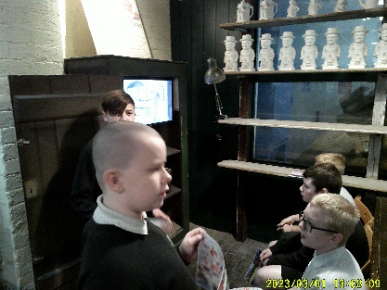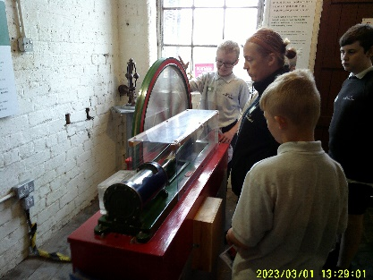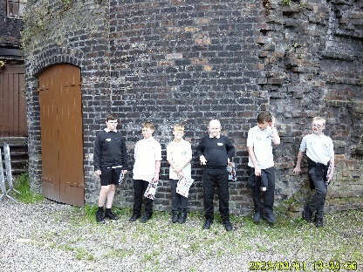

Class Dove – KS2
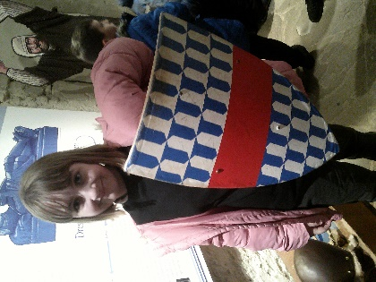
Class Dove have had great fun in History this half term. Students have studied the topic of ‘Invaders and Settlers’ and have explored Anglo-Saxon Britain. Students enjoyed finding out how settlers decided where to build villagers and the process that came with it. They especially enjoyed creating a map of their own Anglo-Saxon village. Rowan said “It was interesting to hear about how important farming and animals were to the Anglo-Saxons' way of life.” Students had a chance to investigate Anglo Saxon artefacts while visiting Tamworth Castle and dress up as Anglo-Saxon warriors. Harry said “I liked playing the games and learning more about Anglo-Saxons. I was good.”
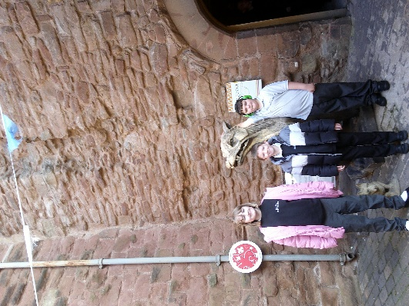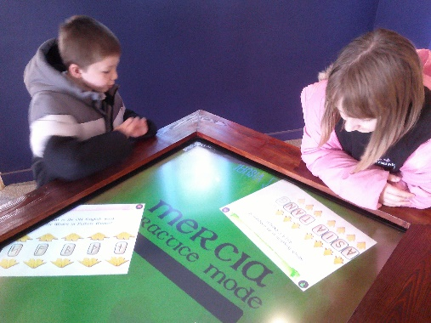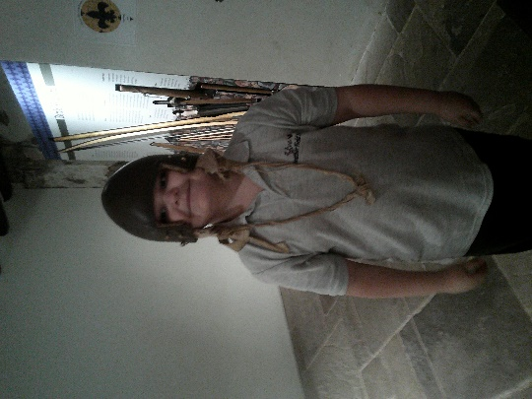

Class Dane
Class Dane have enjoyed music this half term. They began studying grime and hip-hop and a highlight was the pupils using instruments to create their own beats. Harley said, “I don’t normally listen to this sort of music”. They then went on to learn about classical and Bangrha music and explored how the tempos differ. The pupils used interactive software to change and explore how music is created. Joshua really enjoyed stomping and clamping to different beats.
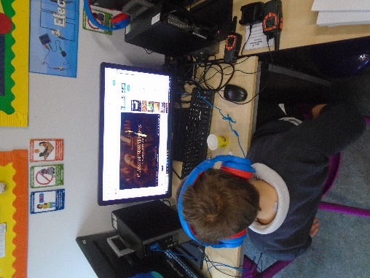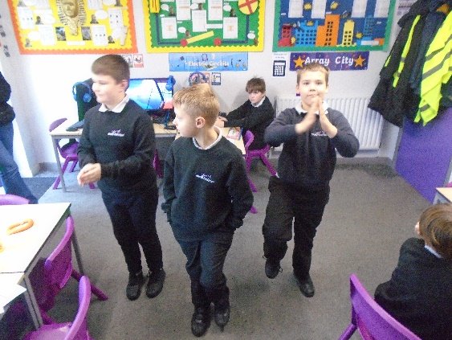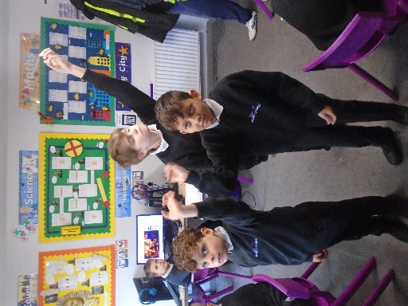

Class Blithe
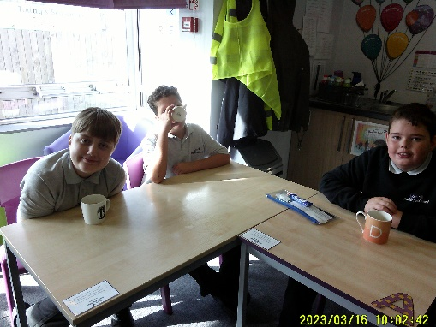
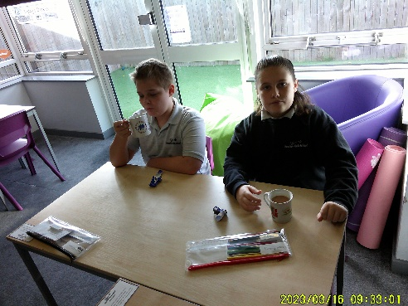
This half term class Blithe have been focusing on personal sensitivity and how they can talk to and tell friends their opinion without offending each other. Pupils started by recognising friendships they have and what makes a good friend. Pupils have particularly enjoyed trying on different funny wigs and listening to peer’s opinions and making themselves a hot drink and interacting socially with each other. James said that having a hot chocolate and talking to friends can help when he is feeling angry or sad.

Class Meese
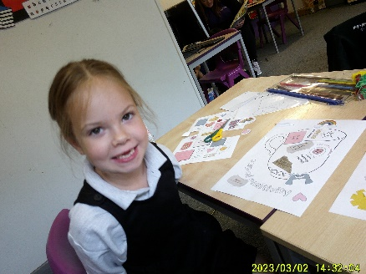
Class Meese have enjoyed our Mental Health Awareness Day this half term. They began by finding out how they can maintain good mental health, including strategies to manage their emotions and remain calm within challenging situations. A highlight of the day was taking part in an animal yoga session in order to help them to relax and strengthen their core muscles. Cooper said, “Yoga is important because it helps us to relax and keep our brains and muscles healthy”. They then went on to play outside, create a cup of positivity picture and a poster identifying why they are an amazing person. All of the children enjoyed our activities throughout the day and could explain the importance of good mental health in order to keep themselves healthy.
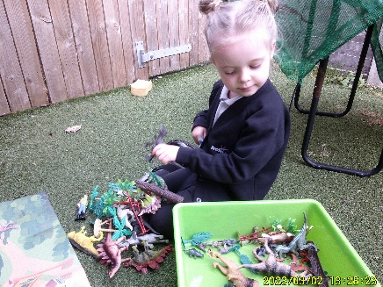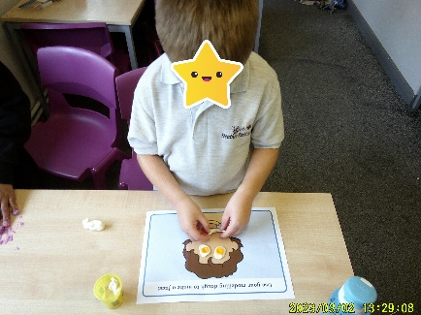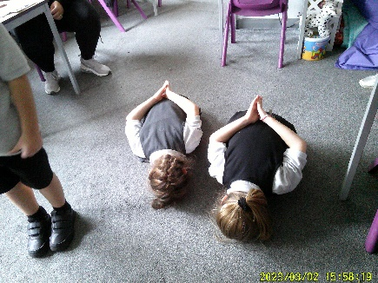
Class Stour
In English KS1 Class Stour have particularly enjoyed listening to stories told in different ways, such as through pantomimes. Florence and Amelie both showed enthusiasm and confidence when partaking in role play activities to retell the stories. Amelie loved being the big bad wolf from ‘The Three Little Pigs’ and ‘huffing and puffing’. In KS2 English they have begun to explore their literacy heritage, listening to ‘The wind in the willows’. George showed high engagement and was able to identify the animals from the film.

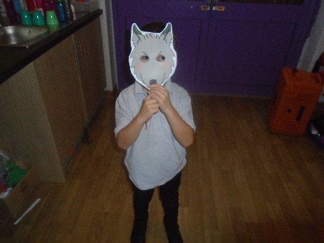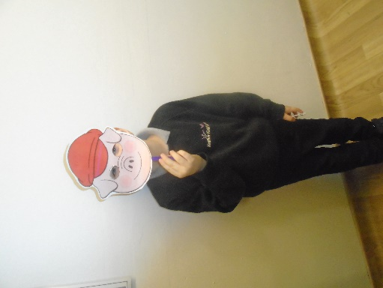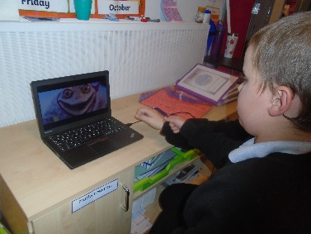

Class Churnet
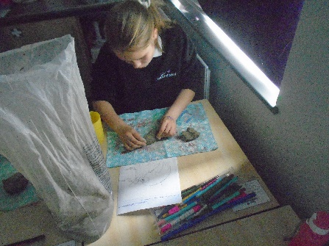
Class Churnet have really enjoyed Art this half term. They have explored mythical creatures, researching the meaning behind how different cultures view mythical creatures for example how western and Chinese have differing views on dragons. Pupils explored a range of printing techniques including ink and leaf printing then designed and created their own mythical created using a range of techniques. The finished products were amazing! TJ said ‘I’m actually proud of that, look how good it looks’.
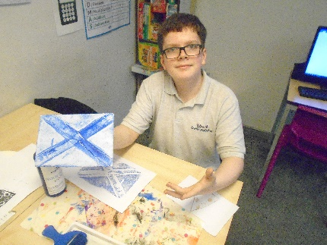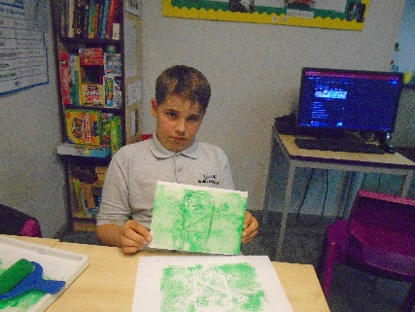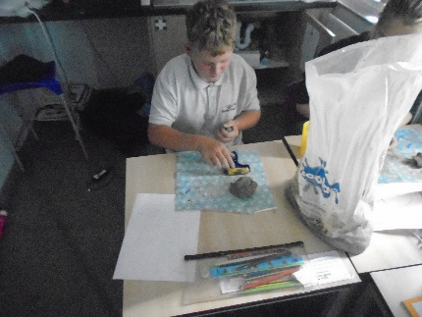

Class Tame
This term in Art class Tame have enjoyed art, the focus has been Pop Art. Shayla enjoyed researching different artists in the Pop Art Genre. She investigated the formal elements of Pop Art and different artists, focussing on Andy Warhol and Roy Lichtenstein. During the half term the class visited Wolverhampton Art Gallery to visit a Pop Art Exhibition.
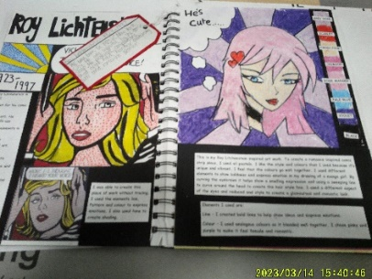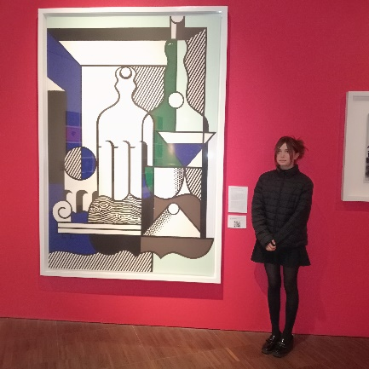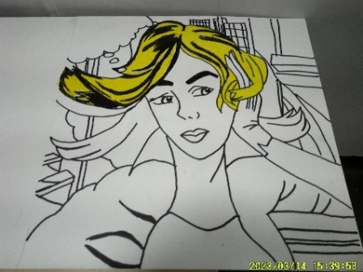

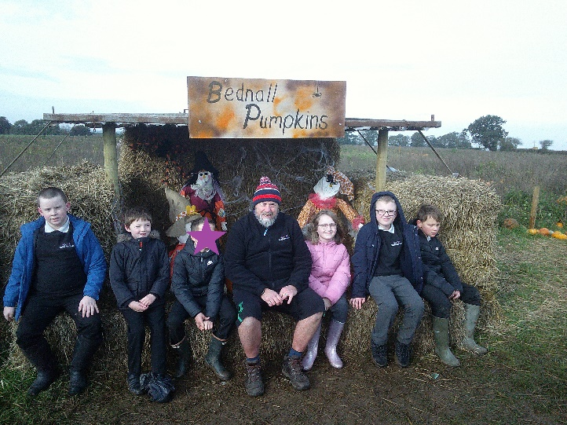
Happy Half Term!
We look forward to seeing you back in school on Monday 6th November 2023.

